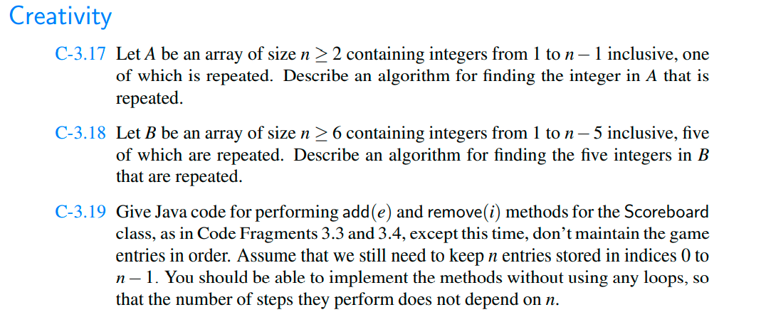



import java.io.\*;  
import java.util.\*;  
*/\*\*  
 \* Created by USER on 17/02/2021.  
 \*/*public class Rwida {  
 int findRepeating(int[] arr, int n)  
 {  
  
 int sum = 0;  
 for (int i = 0; i <=2; i++)  
 sum += arr[i];  
 return sum - (((n - 1) \* n) / 2);  
 }  
   
 public static void main(String args[])  
 {  
 int[] arrys = { 9, 8, 2, 6, 1, 8, 5, 3, 4, 7 };  
 int n = arrys.length;  
 System.*out*.println(findRepeating(arrys, n));  
 }  
 }

import java.io.\*;  
import java.util.\*;  
*/\*\*  
 \* Created by USER on 17/02/2021.  
 \*/*public class Rwida {  
 int findRepeating(int[] arr, int n)  
 {  
  
 int sum = 0;  
 for (int i = 0; i <=6; i++)  
 sum += arr[i];  
 return sum - (((n - 5) \* n) / 2);  
 }  
   
 public static void main(String args[])  
 {  
 int[] arrys = { 9, 8, 2, 6, 1, 8, 5, 3, 4, 7 };  
 int n = arrys.length;  
 System.*out*.println(findRepeating(arrys, n));  
 }  
 }